Delicious House Pastry Shop
Invoice
Date: 31.01.2020
Number 3

To:
Michael M Preston
27 Hendford Hill
MOSELEY
070 2532 1566
By the time: 11:00

Products Ordered:
Product Name | Price, £ | Quantity | Sub Total, £
 Hamburger bun | 4 | 4 | 16
 Rice/lemon/vanilla pudding | 8 | 9 | 72
 Doughnut | 3 | 2 | 6
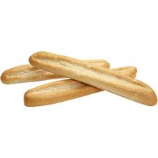 French bread (baguette) | 4 | 4 | 16
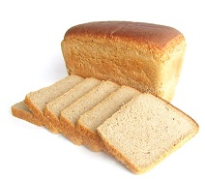 White bread | 3 | 7 | 21
French bread (baguette) | 4 | 9 | 36
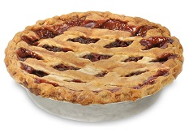 Cherry/apple/pie | 10 | 1 | 10
 |  | Total Cost, £: | £177.00

Enjoy your meal.

